07h July 2016

**YOKOHAMA WIN CLASS AT THE 66TH TRENTO-BONDONE HILL CLIMB**

The talented Italian driver Luca Gaetani, on a YOKOHAMA clad Ferrari achieved a fantastic class victory recently at the prestigious Trento-Bondone Hill Climb.

For the first time the partnership of the Japanese Tyre manufacturer YOKOHAMA supplying the Tyres and Gaetani, on his Ferrari 458 Challenge EVO made by Ram and Vimotorsport achieved the superb result enabling the Venetian Champion the glory of victory in the GT Cup class.

The tyres fitted on the car, were the YOKOHAMA ADVAN A005 in 260/660R19 on the front and 310/690R19 rear. The performance of the tyres over the long and hard race and the extremely good grip was highlighted by the delighted Gaetani after his triumph.

“I’m very satisfied with this result,” – stated Giuseppe Pezzaioli, YOKOHAMA Italy Motorsport Manager – who added, “it is a reward to all the efforts made to win in the hill climbing races, a very hard type of competition that requires top quality tyres”. Pezzaioli also commented that YOKOHAMA has always been successful with their entries in these races and that Luca, decided to trust in the superb performance of the tyres confident on a victory in the GT Cup class. “The win in the class rewarded us too, since the Ferrari 458 Challenge EVO is a prestigious car made by Ram and Vimotorsport, and we should all celebrate this achievement together.” He concluded.

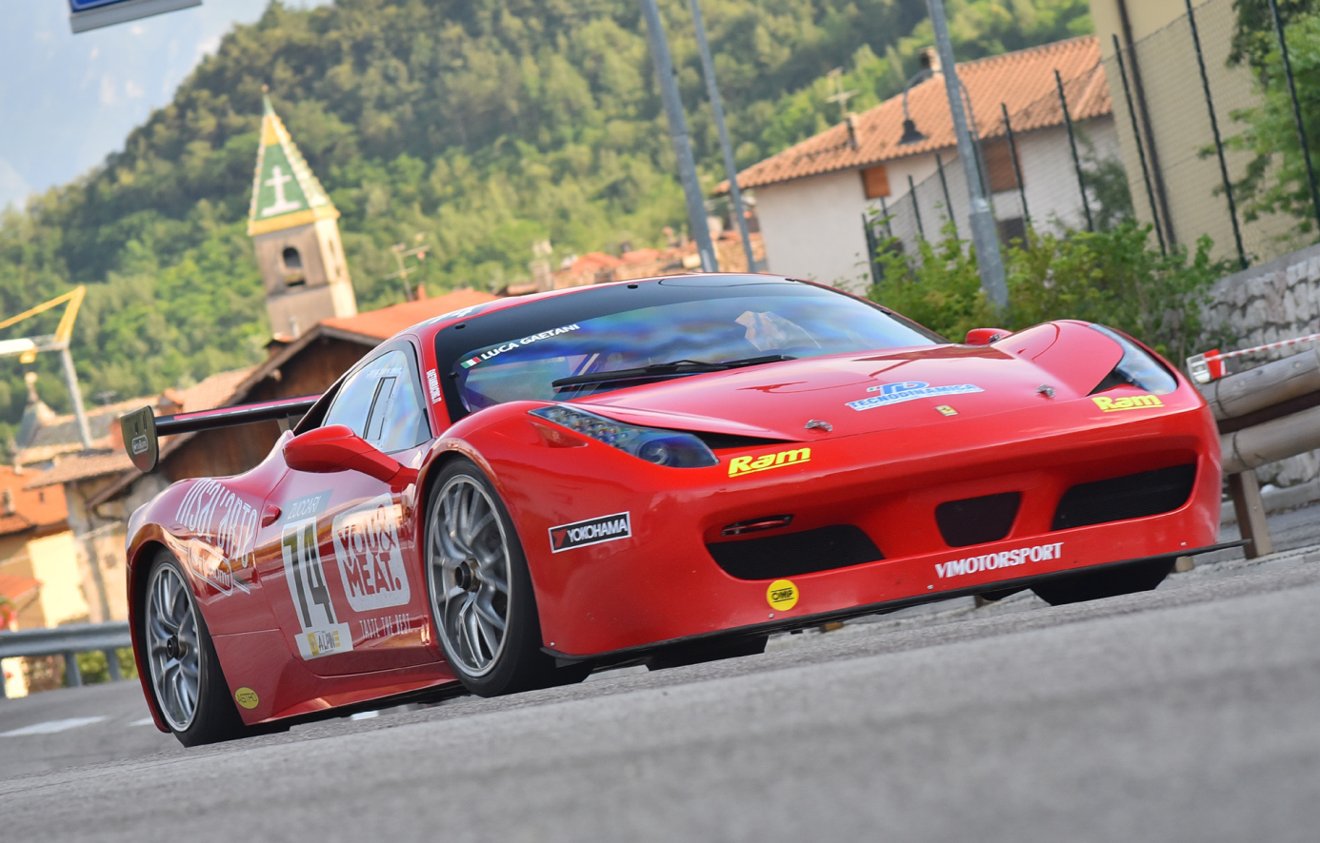

*Luca Gaetani*